**Code-Fury Test Document**

1. **Shipping Cost Calculation**

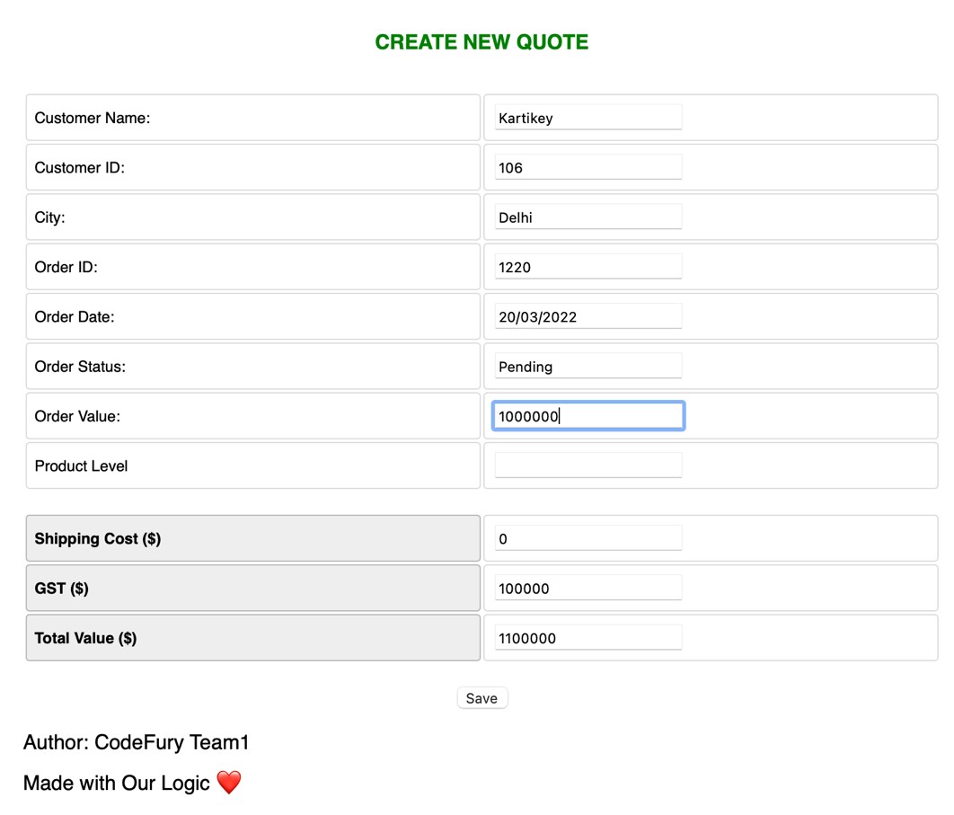

**Level 1**

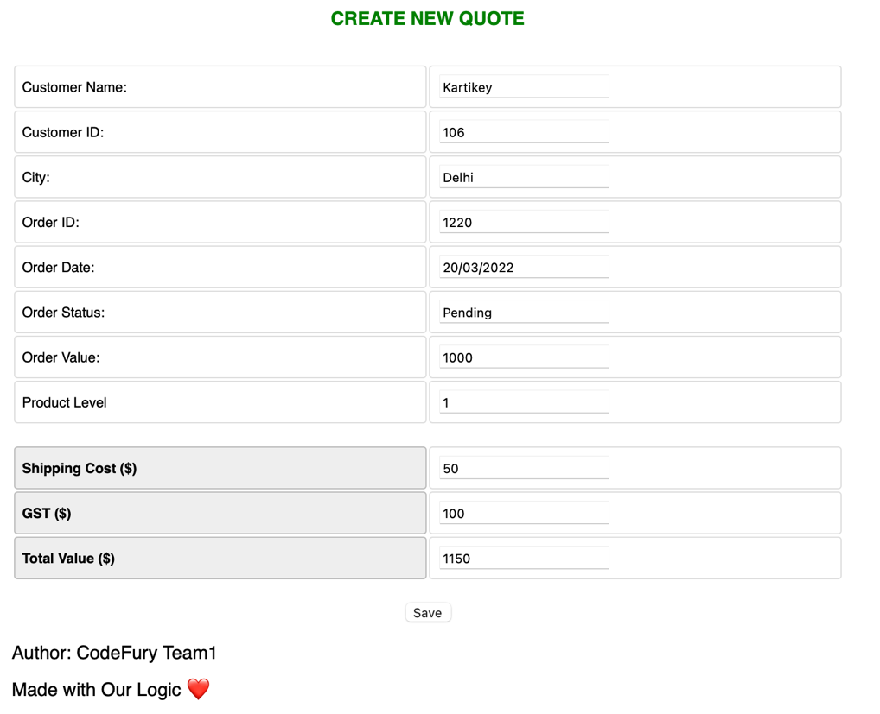

**Level 2**

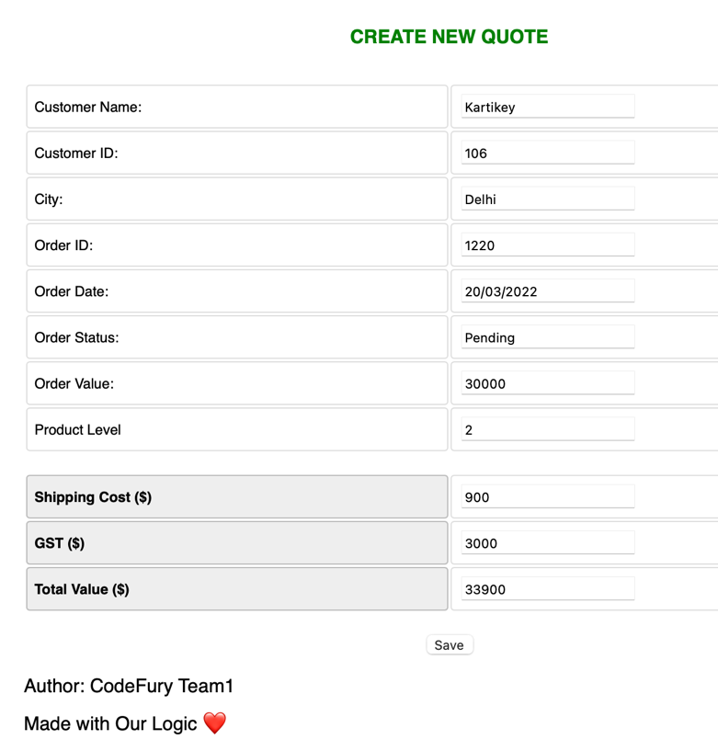

**Level 3**

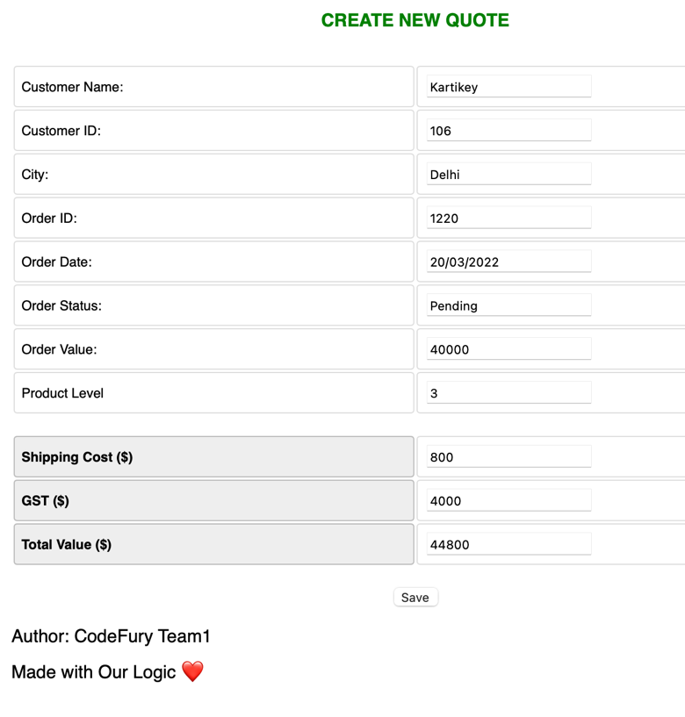

1. **GST Calculation on invoice**

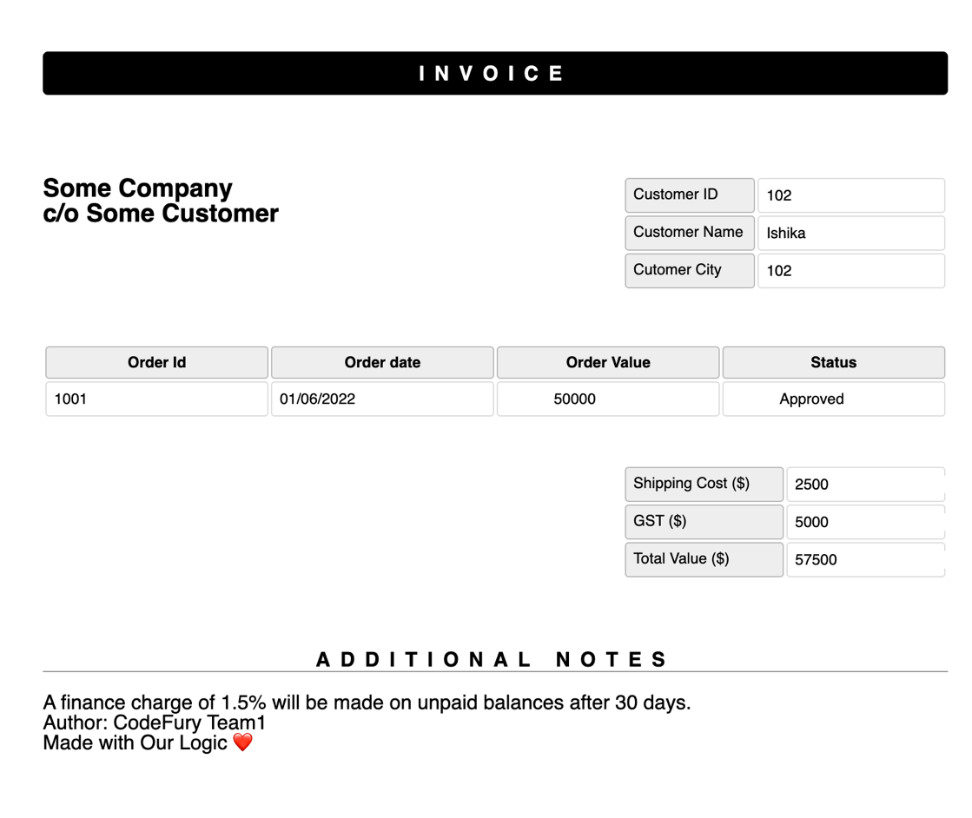

1. **Create New Quote**

All field are mandatory required.

Total price calculated based on levels.

